Command Query Responsibility Segregation (CQRS)
# Source: AI Source: Provided by: [Data Path: Persons Table -> ID Column: 1, Name_En Column: Motasem Essam] -> From: [ChatGPT] on [1/23/2026]
CQRS (Command Query Responsibility Segregation) is an architectural pattern that separates write operations (commands) from read operations (queries).
👉 Instead of one model handling everything, you use two models:
- Command side → modifies data
- Query side → reads data

🔑 Key Idea
# Source: AI Source: Provided by: [Data Path: Persons Table -> ID Column: 1, Name_En Column: Motasem Essam] -> From: [ChatGPT] on [1/23/2026]
- Commands change state (Create, Update, Delete)
- Queries return data (Read)
- Each side can be optimized independently

🧱 Structure
# Source: AI Source: Provided by: [Data Path: Persons Table -> ID Column: 1, Name_En Column: Motasem Essam] -> From: [ChatGPT] on [1/23/2026]
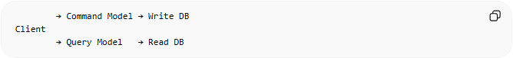
→ Command Model → Write DB
Client
→ Query Model → Read DB
- Command Model → Handles business logic and updates
- Query Model → Optimized for fast reads
- Often uses separate databases

🧩 Example – E-Commerce System
# Source: AI Source: Provided by: [Data Path: Persons Table -> ID Column: 1, Name_En Column: Motasem Essam] -> From: [ChatGPT] on [1/23/2026]
Command Side
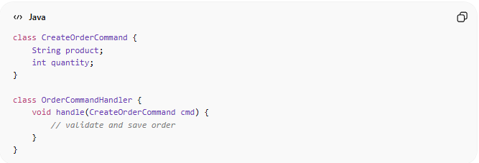
class CreateOrderCommand {
String product;
int quantity;
}

class OrderCommandHandler {
void handle(CreateOrderCommand cmd) {
// validate and save order
}
}

Query Side
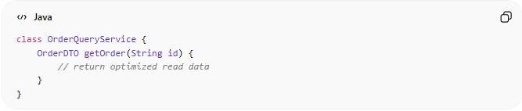
class OrderQueryService {
OrderDTO getOrder(String id) {
// return optimized read data
}
}

❌ Bad Example (No CQRS)
# Source: AI Source: Provided by: [Data Path: Persons Table -> ID Column: 1, Name_En Column: Motasem Essam] -> From: [ChatGPT] on [1/23/2026]
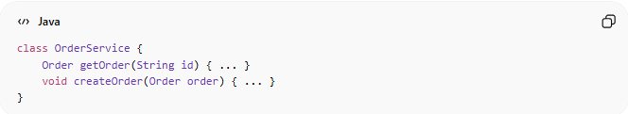
class OrderService {
Order getOrder(String id) { ... }
void createOrder(Order order) { ... }
}
👉 Problems:
- Same model handles read + write
- Hard to scale
- Conflicting requirements (performance vs consistency)

✅ Good Example (Using CQRS)
# Source: AI Source: Provided by: [Data Path: Persons Table -> ID Column: 1, Name_En Column: Motasem Essam] -> From: [ChatGPT] on [1/23/2026]
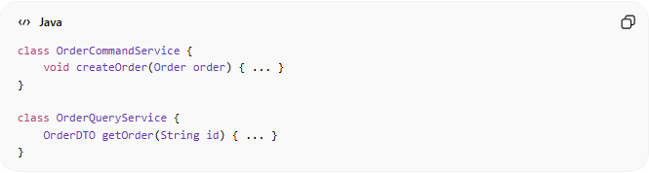
class OrderCommandService {
void createOrder(Order order) { ... }
}

class OrderQueryService {
OrderDTO getOrder(String id) { ... }
}
👉 Benefits:
- Clear separation
- Easier to scale reads and writes independently
- Optimized performance

🔄 CQRS + Event Sourcing (Powerful Combo)
# Source: AI Source: Provided by: [Data Path: Persons Table -> ID Column: 1, Name_En Column: Motasem Essam] -> From: [ChatGPT] on [1/23/2026]
- CQRS separates read/write
- Event Sourcing stores changes as events
Command → Event → Event Store → Read Model (updated asynchronously)
👉 This allows:
- Real-time updates
- Full history tracking
- High scalability

🔄 Use Cases
# Source: AI Source: Provided by: [Data Path: Persons Table -> ID Column: 1, Name_En Column: Motasem Essam] -> From: [ChatGPT] on [1/23/2026]
- Large-scale systems (e-commerce, banking)
- Applications with heavy reads or writes
- Systems needing high performance and scalability

⚠️ Common Mistakes
# Source: AI Source: Provided by: [Data Path: Persons Table -> ID Column: 1, Name_En Column: Motasem Essam] -> From: [ChatGPT] on [1/23/2026]
- Using CQRS for simple apps ❌ (overengineering)
- Not syncing read/write models properly ❌
- Adding unnecessary complexity ❌

💡 Key Idea
# Source: AI Source: Provided by: [Data Path: Persons Table -> ID Column: 1, Name_En Column: Motasem Essam] -> From: [ChatGPT] on [1/23/2026]
CQRS separates what changes data from what reads data, allowing each to be optimized independently

🧾 Summary
# Source: AI Source: Provided by: [Data Path: Persons Table -> ID Column: 1, Name_En Column: Motasem Essam] -> From: [ChatGPT] on [1/23/2026]
- Command = Write
- Query = Read
- Improves scalability, performance, and clarity
- Often used with Event Sourcing

